Visit to Norway
(20-22 October 2025)

LIST OF PARTICIPANTS
of the delegation of the Ukrainian Council of Churches and Religious Organizations

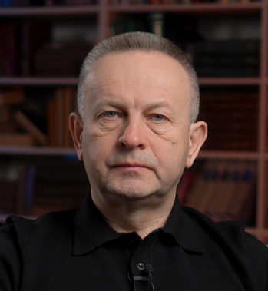 | 1. Senior Bishop Valerii Antoniuk  All-Ukrainian Union of the Churches of Evangelical Christians-Baptists  Chairman of the UCCRO, Head of the All-Ukrainian Union of the Churches of Evangelical Christians-Baptists  *Basic English (interpreter needed)
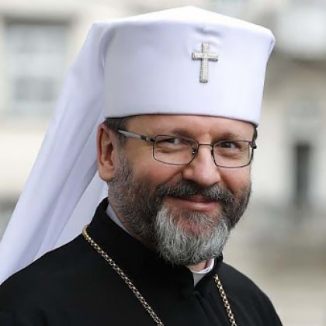 | 2. His Beatitude Sviatoslav Shevchuk  Ukrainian Greek-Catholic Church  Father and Head, Major Archbishop of Kyiv-Halych  *Fluent English
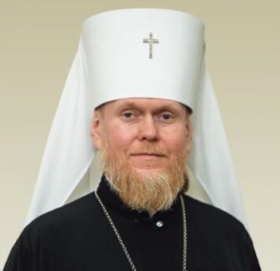 | 3. Met. Yevstratiy (Zoria)  Orthodox Church of Ukraine  Metropolitan of Bila Tserkva, Spokesman for the Orthodox Church of Ukraine  *Fluent English
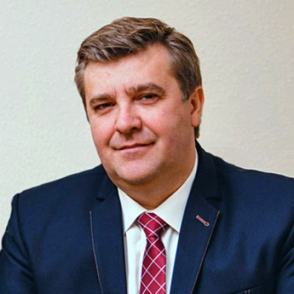 | 4. Senior Bishop Anatoliy Kozachok  Ukrainian Church of the Christians of Evangelical Faith (Ukrainian Pentecostal Church)  *Basic English (interpreter needed)
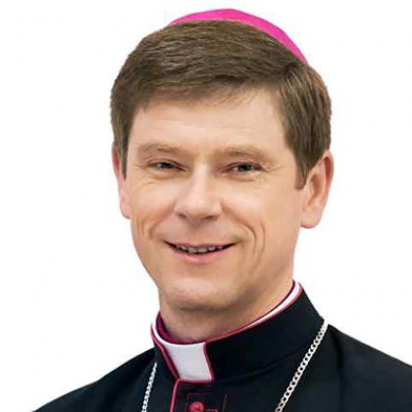 |  | 5. Bishop Vitalii Kryvytskyi  Roman Catholic Church in Ukraine  Bishop of the Roman Catholic Church in Ukraine, Ordinary of Kyiv-Zhytomyr  *Basic English (interpreter needed)
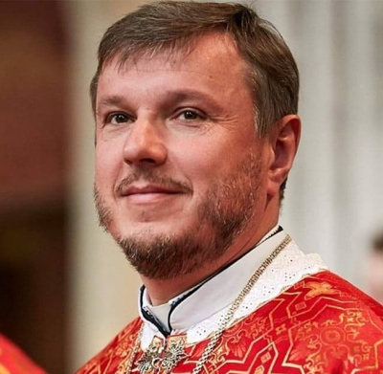 |  | 6. Fr. Oleh Oleksa  Ukrainian Greek-Catholic Church  Archpriest  *Basic English (interpreter needed)
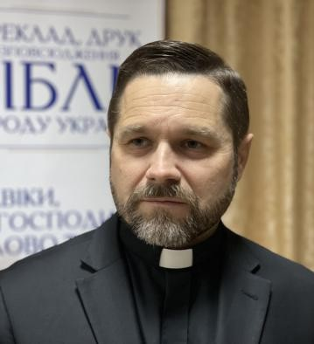 |  | 7. Rev. Anatoliy Raychynets  Ukrainian Bible Society  Deputy Secretary General of the Ukrainian Bible Society, Pastor of the Ukrainian Evangelical Church  *Fluent English
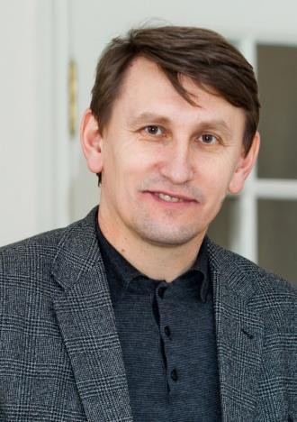 |  | 8. Mr. Oleksandr Zaiets  Institute for Religious Freedom (NGO)  Head of the Board  *Basic English (interpreter needed)

